Chapter 3, Problem 74.

By inspection, obtain the mesh-current equations for the circuit in Fig. 3.118.

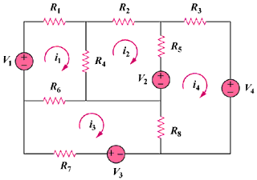

Figure 3.118
For Prob. 3.74.

